Breakfast
$8.00 Per Person and Includes the Following
Scrambled Eggs, Pancakes, Choice of Bacon or Sausage and Panfries. *Includes syrup, butter, s&p and ketchup*
10 Person Minimum
Other Breakfast Options
Sausage Gravy & Biscuits 8-10 Servings $30.00 12-20 Servings $55.00
Homemade Muffins $21.00 a Dozen
Mini Muffins $14.00 for 2 Dozen
Muffin Flavors: Blueberry, Banana, Chocolate Chip, Brown Sugar, Lemon Poppy and Cranberry Orange (seasonal)
**Flavors can be mixed by the ½ dozen**
Whole Breakfast Breads $6.00
Bread Flavors: Banana, Pumpkin, Apple Cinnamon, Date, Blueberry, Cranberry and Lemon Poppy
Homemade Desserts
Homemade Bread Pudding (serves 8-10) $15.95
Award Winning Apple Pie (serves 6-8) $13.95
Pineapple Upside Down Cake $11.95

If There is Something You Had in Mind
That is Not on Our Menu Please Ask!

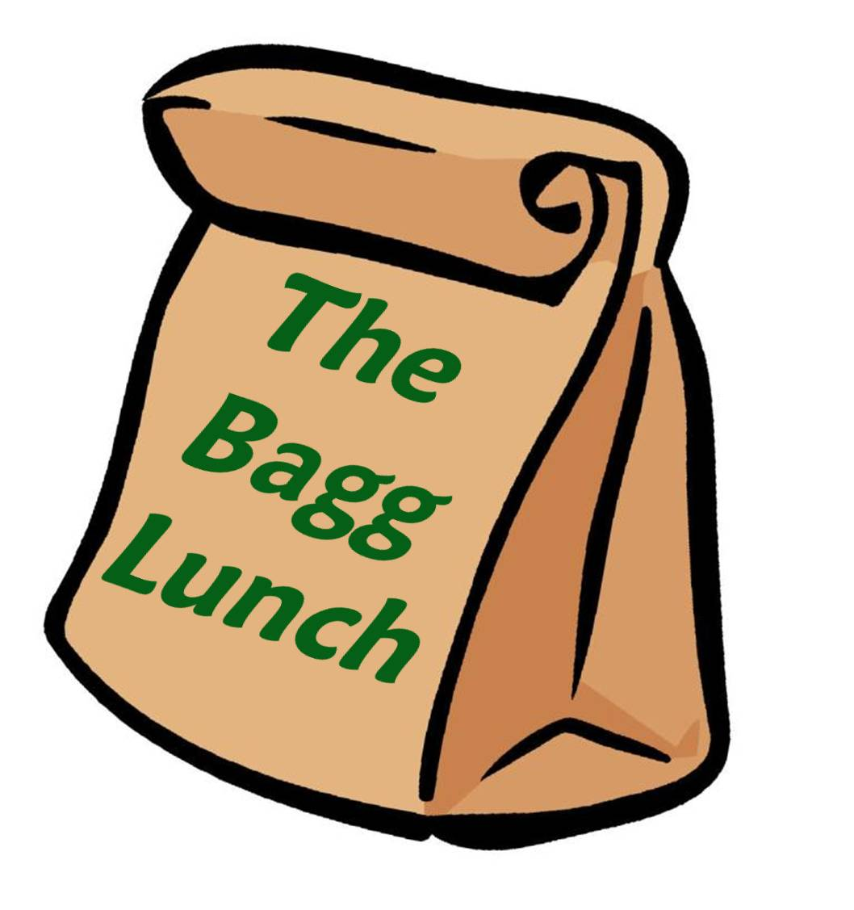

Catering Menu
679 Mast Road Manchester, NH 03102 (603) 935-7053
www.thebagglunch.com
Cold Sandwiches, Salads & Side Dishes

Serves 8-12 Serves 12-18
Homemade Macaroni Salad 20.00 35.00
Homemade Red Bliss Potato Salad 20.00 35.00
Fresh Fruit Platter 28.00 40.00
Cheese, Crackers & Pepperoni 45.00 70.00
Veggie Platter with Ranch Dressing 22.00 40.00
Rolled Meat & Cheese Platter 60.00 90.00
Finger Sandwiches 20.00/dozen
Wrap Platter 20.00 35.00
Garden Salad 20.00 35.00
Chef Salad 30.00 45.00
Antipasto 35.00 50.00
Greek Salad 35.00 50.00
Caesar Salad 22.00 38.00
Add Chicken to Any Salad 12.00 20.00
Available Dressings: Greek, Caesar, Ranch, Thousand Island, Italian,
French and Balsamic Vinaigrette.
Bagged Lunches
Are Available $8.00 Per Person and Include Your Choice
Ham & Cheese, Turkey & Cheese or Tuna on a Bulkie Roll.
Potato Chips
Cookie or Brownie
Apple
Bottle Soda or Water

Hot Meals and Sides Dishes

Serves 8-12 Serves 12-18
Stuffed Shells (with meat sauce) 30.00 55.00
Lasagna (with meat sauce) 35.00 60.00
Chinese Pie 28.00 42.00
Stuffed Peppers 28.00 42.00
Chicken Pot Pie 40.00 60.00
Baked Mac & Cheese 28.00 42.00
Chicken Tenders 45.00 65.00
Swedish Meatballs 25.00 40.00
Pulled Pork 45.00 70.00
Kielbasa 35.00 45.00
Fresh Cut French Fries 18.00 26.00
Homemade Mashed (Red Bliss) 20.00 30.00
Homemade Baked Beans 35.00 50.00
Pork Pie (4-8 Servings) 16.00 each
Quiche (4-8 Servings) 12.00 each
(Choice of Broccoli, Spinach, Veggie or Bacon. Requests Welcome)
Bread & Butter 6.00 10.00

*Free Delivery within 10 Miles*
*Plates, Napkins and Utensils Available for $1.00 per person*
*Catering/Delivery Are Available After Regular Business Hours*
*Servers Available at $12.00 per server/per hour*

